**Performance Test Report**

**for**

**Execution of**

**Kernel Crypto-manager – 250 users**

Date: 02 June 2020

Author: Gaurav Sharan

**Summary**

This report presents the observations and findings of the load test conducted for a load of 250 users on kernel crypto-manager services.

The objective of this load test was to observe and record behavior of the application when user load is increased from 100 to 250.

Below are the scenario details:

|  |  |
| --- | --- |
| **Script/Report Name** | Kernel crypto-manager Service |
| **Run Date** | 02-June-2020 |
| **Period** | 09:07:56 UTC to 10:06:31 UTC |
| **Number of concurrent users** | 100 to 250 |
| **Ramp up** | 01 user per second |
| **Run Duration** | --- |
| **Ramp down** | NA |

The transaction response times observed were as below:

|  |  |  |  |  |  |  |  |
| --- | --- | --- | --- | --- | --- | --- | --- |
| **Label** | **# Samples** | **Average(ms)** | **90% Line(ms)** | **Min(ms)** | **Max(ms)** | **Error %** | **Throughput** |
| TR_reg-proc_encrypt | 298195 | 654 | 68 | 7 | 60117 | 52.08% | 84.83562 |
| TR_reg-proc_decrypt | 142907 | 644 | 102 | 9 | 60024 | 0.22% | 50.31426 |

**Performance Test Execution Details**

We have executed JMeter script for kernel crypto-manager service, which has transactions mentioned in the above table.

Average response time of the APIs is 640 ms with error rate 52 % for encrypt API, error started appearing for encrypt and decrypt APIs at 225 users load, and error volume increased for encrypt API at 250 users load.

**Response Time and TPS Graph:**

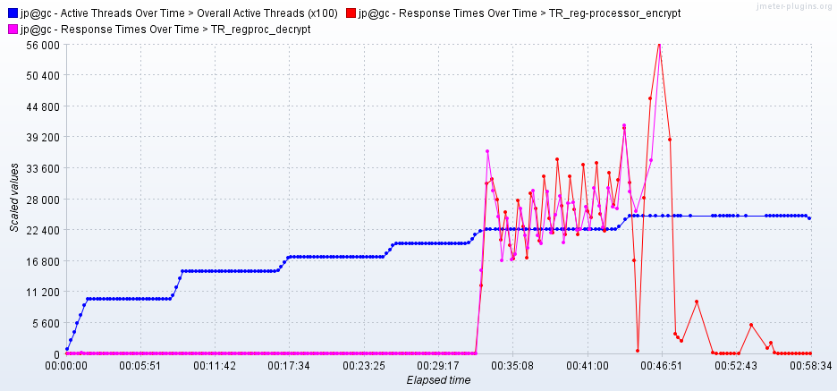

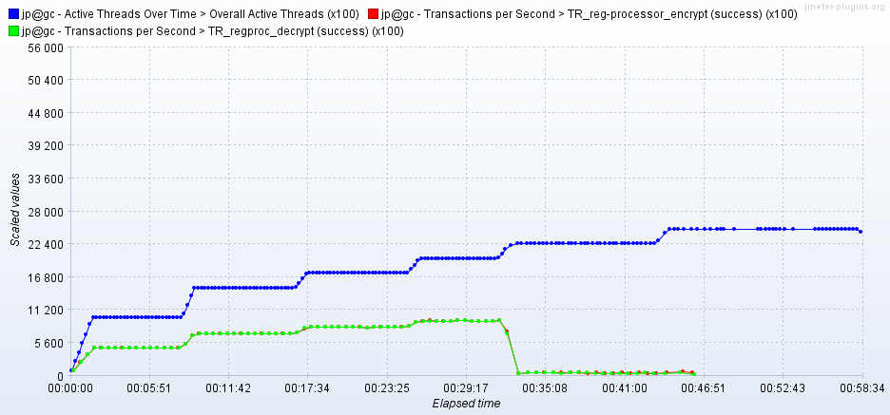

As seen in the response time graph, response time of the APIs increases 20 seconds when 225 users are active, after that application crashes at 250 users level.

Throughput (TPS) of the APIs reaches 95 when 200 users are active and comes down for higher number of uses. Cryptomanager service crashes at a user load of 250.